Biometric Attendance System - Production-Ready Architecture
This document outlines the evolutionary design of the Attendix platform, transitioning it from a stateless processing tool to a scalable, persistent, and secure office management system.
🏗️ High-Level System Architecture
The system follows a classic 3-tier architecture for modularity and scalability.

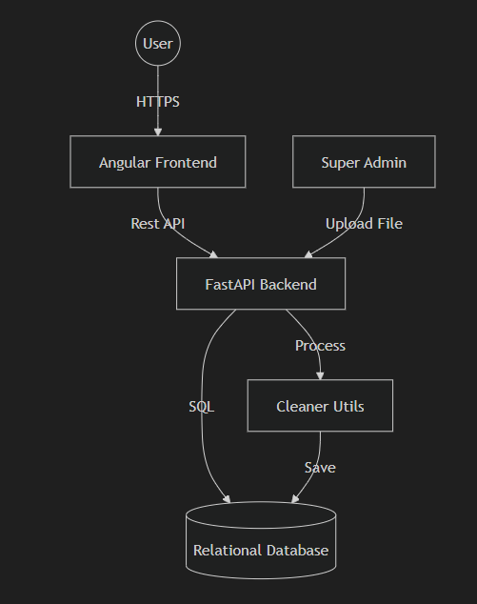

Components:-
- Frontend (Angular): Responsible for visualization, role-based routing, and interactive reports.
- Backend (FastAPI): Handles authentication, file processing logic (Pandas), and database orchestration.
- Database (PostgreSQL/MySQL): Stores employee records, attendance history, and audit logs.

🔐 Role-Based Access Control (RBAC) Strategy
The system enforces strict data isolation based on roles.
Role | Permissions | Data Scope
Super Admin | Full CRUD, User Management, File Upload | Entire Company
HR User | Read-Only Access, Reporting | Entire Company
Employee | Read-Only Access | Self-only (Record filtered by EmpID)
Authorization Mechanism
- JWT (JSON Web Tokens): Securely transmit claims (Role, EmpID) between client and server.
- Middleware: Backend decorators to verify permissions before executing sensitive operations (e.g., @require_role('SUPER_ADMIN')).
- Data Query Isolation: Queries for 'Employee' role will always append a WHERE emp_id = :session_id clause to prevent unauthorized data access.

🗄️ Database Design
A relational design ensures data integrity and historical accuracy.
1. Employee Master Table
Stores identity and authentication details.
- id (PK)
- employee_id (Unique, used in biometric logs)
- name
- email
- password_hash
- role (ENUM: SUPER_ADMIN, HR, EMPLOYEE)
- status (Active, Inactive)
- created_at, updated_at

2. Attendance Daily Logs (Aggregated)
Stores daily processed data for quick reporting.
- id (PK)
- employee_id (FK)
- date (Date)
- first_in (Time)
- last_out (Time)
- total_duration (Interval/Minutes)
- status (Present, Absent, Half-Day)
- source_file_id (FK for traceability)

3. File Upload Audit
Tracks source files for accountability.
- id (PK)
- filename
- uploaded_by (FK)
- upload_timestamp
- report_type (Type A or Type B)

🗺️ Normalization & Indexing
- Composite Index:
(employee_id, date) on logs to speed up monthly report generation.
- Partitioning: If scaling to thousands of employees, partition the attendance table by month/year.

🔄 Data Lifecycle & ETL Process
- Extract: Super Admin uploads raw
.xls/.csv.
- Transform:
  - Backend parses file using cleaner_utils.py.
  - Data is validated (Detects missing IDs, malformed timestamps).
  - Deduplication logic ensures same day records aren't duplicated.
- Load: Records are persisted to the database.
- Correction Flow: If an Admin modifies a record, the original biometric data is preserved, but a manual_correction flag and corrected_by column are updated.

Risks, Edge Cases & Future Extensions
Risks & Edge Cases
- Overlapping Uploads: Handling cases where an admin uploads the same month twice (Idempotency).
- Timezone Conflicts: Ensuring server and biometric device timestamps are synchronized (UTC recommended for storage).
- EmpID Mismatch: Handling raw files where EmpID doesn't exist in the Employee Master.
Future Extension Ideas
- Mobile Integration: Geo-fencing for remote check-ins.
- AI Forecasting: Predictive analytics for employee absence trends.
- Multitenancy: Supporting multiple offices or sub-companies in one instance.
- Leave Management Integration: Automatically marking "Present" vs "Leave" by syncing with HRMS.

> Verification Plan
This design will be verified against the requirements through structural review.
Structural Verification
- Ensure all 3 roles have distinct defined paths.
- Validate that the database schema supports "Correction Traceability".
- Confirm the architecture supports "Historical Data Preservation" via snapshots/persistence.

